# **Steps to run python code**

1. Downloads:

1.1 Python

<https://www.python.org/downloads/>

* 1. Anaconda

<https://www.anaconda.com/download/>

* 1. Pip
     1. Open Command line: >> py get-pip.py
     2. >> set PATH=%PATH%;*C:\Users\12sha\Anaconda3\Scripts*

(this path can be found using python script

import os

import sys

os.path.dirname(sys.executable))

* + 1. now you can install anything using pip

e.g.: pip install geopy

1. Download Github source code:

<https://github.com/shank121991/winthesislocation>

1. Download Microsoft Geolife data

<https://www.microsoft.com/en-us/download/details.aspx?id=52367&from=https%3A%2F%2Fresearch.microsoft.com%2Fen-us%2Fdownloads%2Fb16d359d-d164-469e-9fd4-daa38f2b2e13%2F>

1. Now you have all the setup:

4.1 Open anaconda navigator and launch jupyter notebook

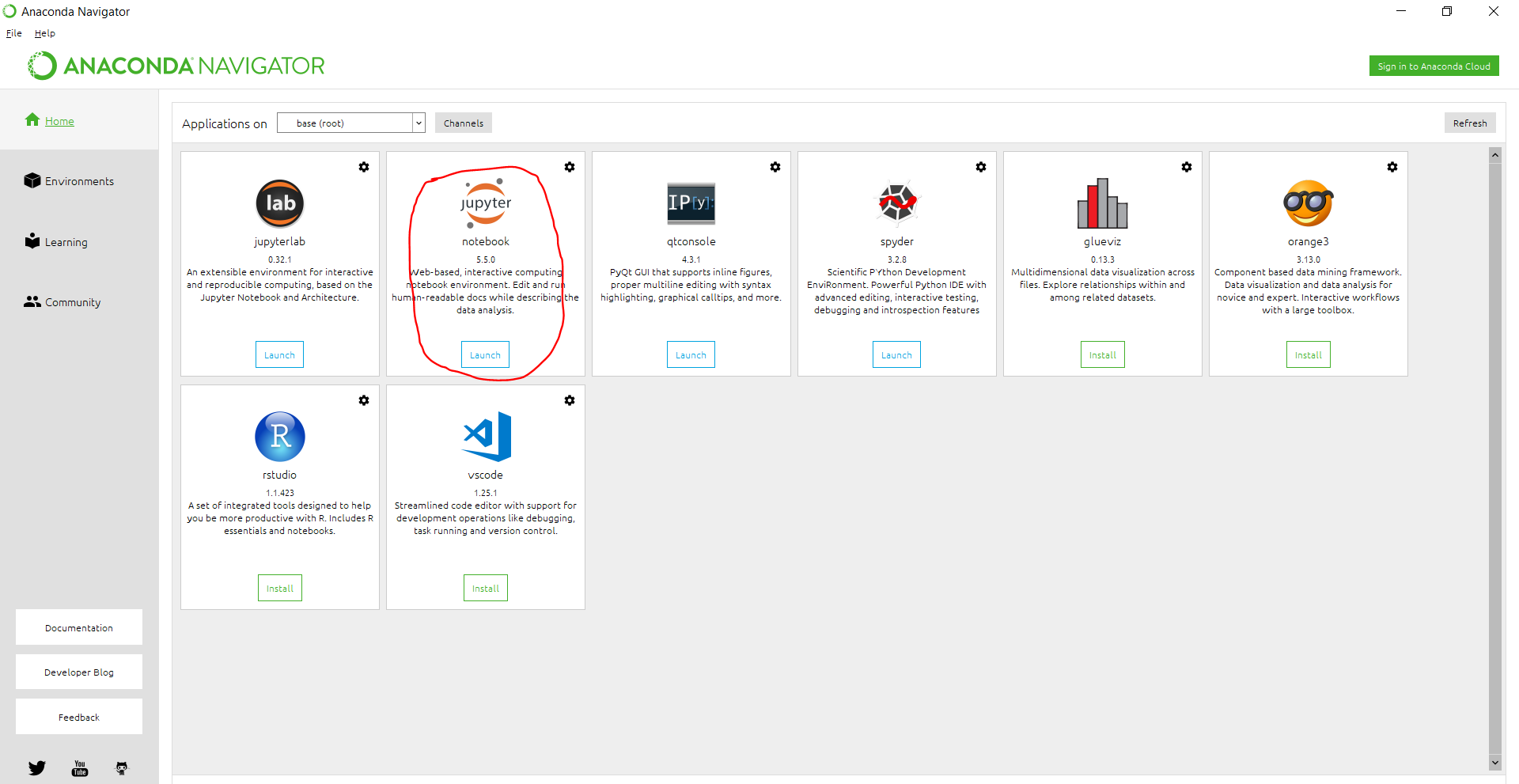

* 1. Now navigate to the github local location in jupyter notebook

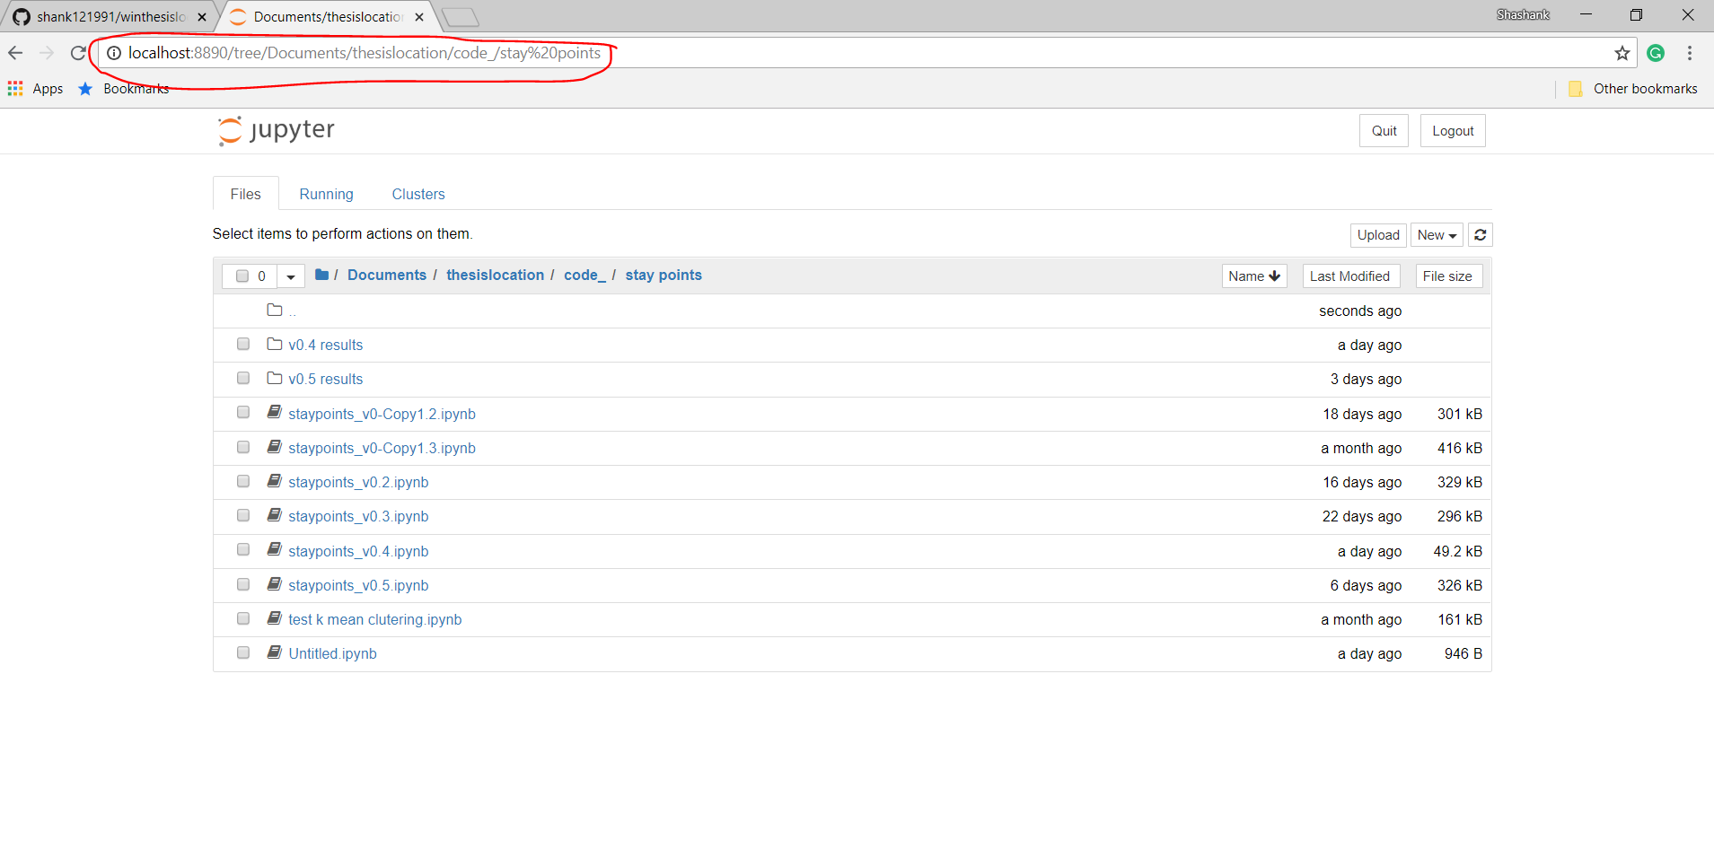

4.3 Change the Geolife User and file location in the program accordingly and run the desired code using shift + enter key